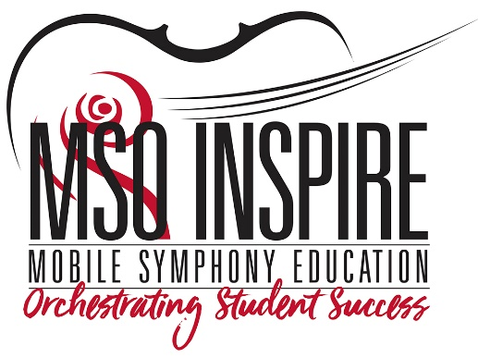
Lily & the Bull Shark
Mobile Symphony Post-Performance Survey for Teachers

- Did the music element of the performance meet your expectations? Why or why not?

- Did you find the study guide and curriculum materials helpful? Which were most appropriate? Would you suggest any changes?

- Was the program age-appropriate for your students?

- Did your students enjoy the program? How did they communicate this?

- Would you like more in-school performances for your students?

- Would you consider bringing your class to attend a Mobile Symphony Young People’s Concert at the Saenger Theatre in the future?

- Do you have any suggestions to improve this program?

